Sending Emails with a Flexy
Created By: Tim Beaulieu
Version 1.0
Created on: 5/7/2019
Last Updated: 5/8/2019

Contents
Step 1: Required settings 3
Step 2: Emails through Tags 4
Creating the Tags: 4
Email Settings: 5
Part 3: Emails Through BASIC IDE 5
Email to SMS Relays 6
Included code: 7
Example of Received Email: 7

Step 1: Required settings
Make sure that you have a usable SMTP server such as relay.talk2m.com with the port 25.
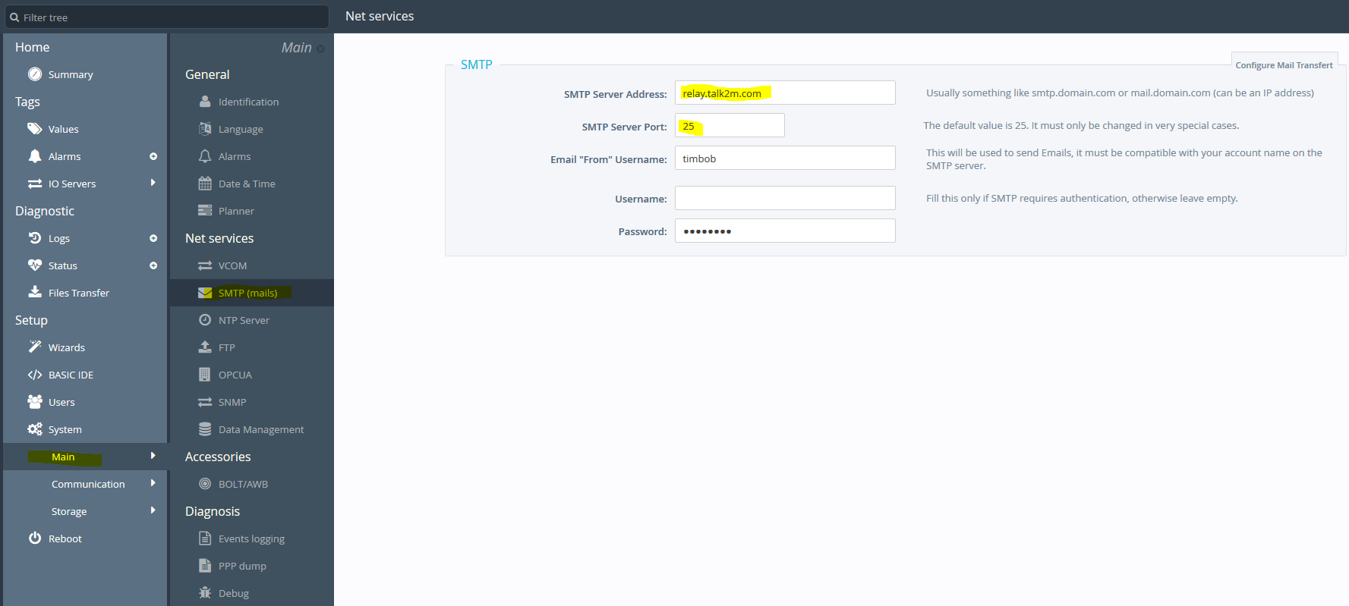
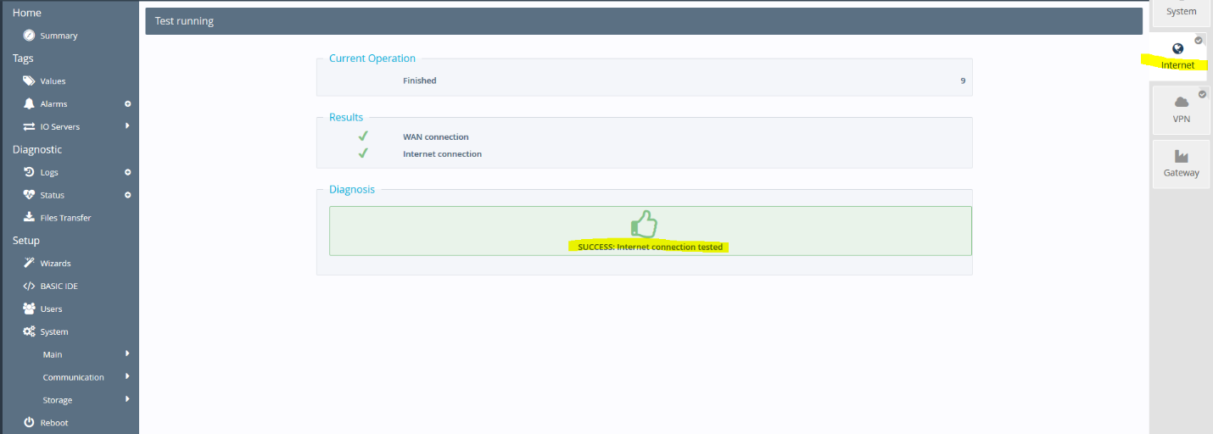
Next make sure that your device has passed the internet wizard

Step 2: Emails through Tags

Creating the Tags:
You can have up to 4 different alarms per tag with these settings.
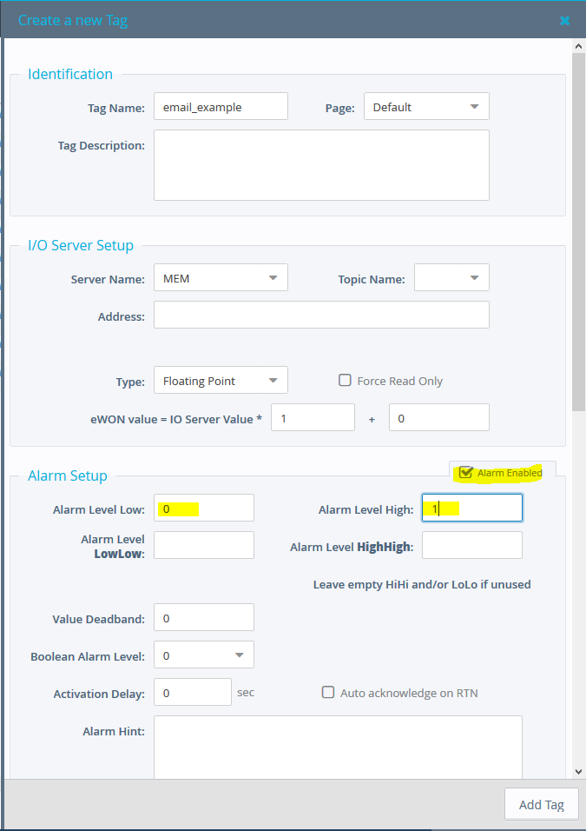

Email Settings:
Once this is done, you’ll need to double click on the bell’s checkmark for the tag. You’ll also need to choose who you’re sending your email to. If you want to send the email to multiple people, you can do this by separating them with a semicolon. You can also choose what attachments are going to be sent in the email by using the EBD helper: https://ewonsupport.biz/ebd/
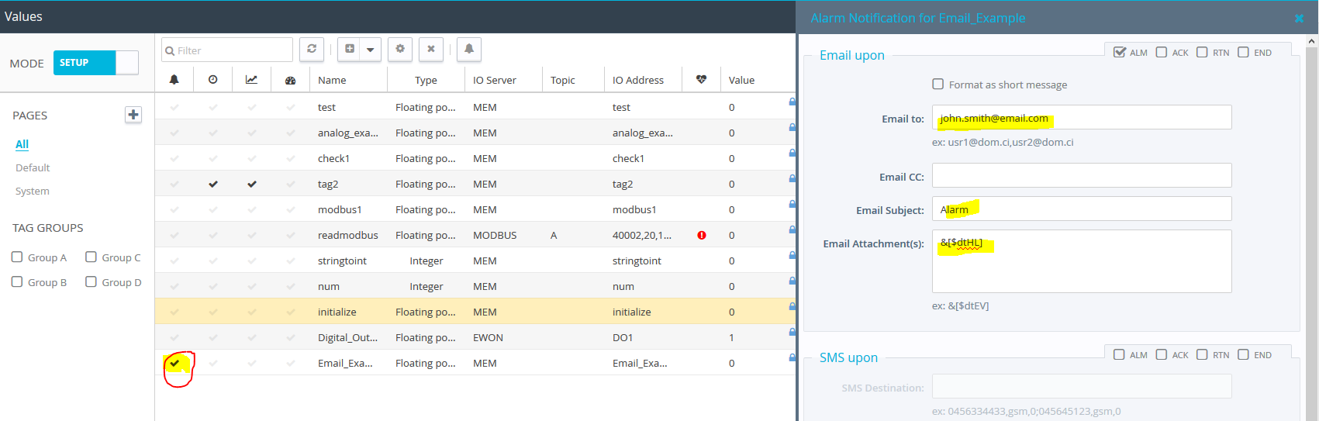

Step 3: Emails Through BASIC IDE
The code below is setup to be activated whenever the tag “Email_Example” changes but will only send an email when the value of Email_Example’s value is set to 1. It also has examples on including values inside the email. For example, I have a tag called Digital Example and Analog Example that are called and will show up in the Email.
Note: Make sure to put this code in the Init section instead of the Cyclic section. The Cyclic section will run every processor cycle and will likely cause the device to reboot if too much is done at once.
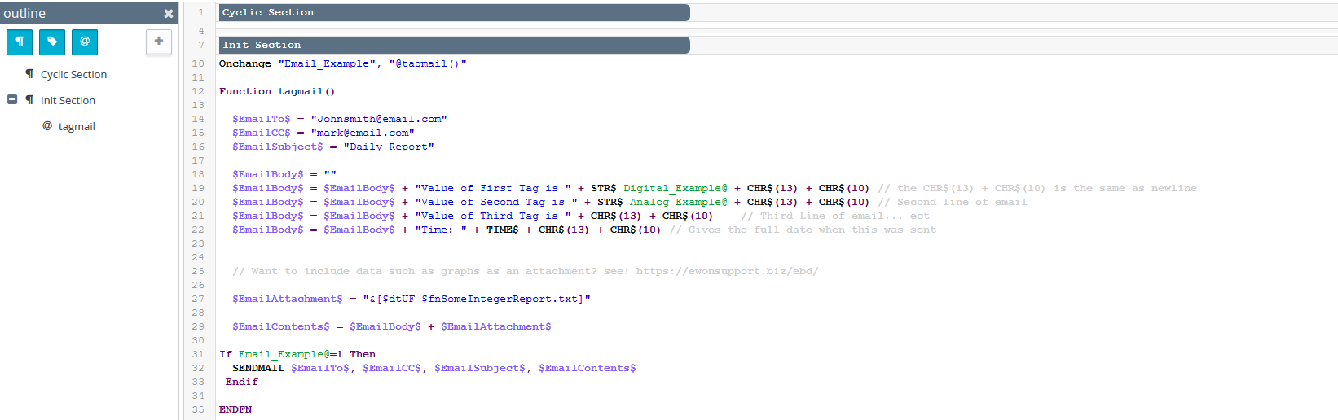

Email to SMS Relays
For U.S. Customers most of the cellular providers have an Email to SMS relay. By doing this you can essentially email a text to your phone. You’ll just need to follow the format below and can place these alongside the people that you’re emailing.
Carrier | SMS gateway domain | MMS gateway domain
Alltel | phonenumber@message.alltel.com | phonenumber@mms.alltelwireless.com
AT&T | phonenumber@txt.att.net | phonenumber@mms.att.net
Boost Mobile | phonenumber@myboostmobile.com | phonenumber@myboostmobile.com
Cricket Wireless |  | phonenumber@mms.cricketwireless.net
Project Fi |  | phonenumber@msg.fi.google.com
Sprint | phonenumber@messaging.sprintpcs.com | phonenumber@pm.sprint.com
T-Mobile | phonenumber@tmomail.net | phonenumber@tmomail.net
U.S. Cellular | phonenumber@email.uscc.net | phonenumber@mms.uscc.net
Verizon | phonenumber@vtext.com | phonenumber@vzwpix.com
Virgin Mobile | phonenumber@vmobl.com | phonenumber@vmpix.com

Included code:
Onchange "Email_Example", "@tagmail()"
Function tagmail()
$EmailTo$ = "Johnsmith@email.com"
$EmailCC$ = "mark@email.com"
$EmailSubject$ = "Daily Report"
$EmailBody$ = ""
$EmailBody$ = $EmailBody$ + "Value of First Tag is " + STR$ Digital_Example@ + CHR$(13) + CHR$(10) // the CHR$(13) + CHR$(10) is the same as newline
$EmailBody$ = $EmailBody$ + "Value of Second Tag is " + STR$ Analog_Example@ + CHR$(13) + CHR$(10) // Second line of email
$EmailBody$ = $EmailBody$ + "Value of Third Tag is " + CHR$(13) + CHR$(10) // Third Line of email... ect
$EmailBody$ = $EmailBody$ + "Time: " + TIME$ + CHR$(13) + CHR$(10) // Gives the full date when this was sent
// Want to include data such as graphs as an attachment? see: https://ewonsupport.biz/ebd/
$EmailAttachment$ = "&[$dtUF $fnSomeIntegerReport.txt]"
$EmailContents$ = $EmailBody$ + $EmailAttachment$
If Email_Example@=1 Then
SENDMAIL $EmailTo$, $EmailCC$, $EmailSubject$, $EmailContents$
Endif
ENDFN

Example of Received Email:

