NAT 1:1 On a LAN without VPN
Created By: Tim Beaulieu
Version 1.0
Created on: 4/9/2019
Last Updated: 4/9/2019

Contents
Step 1: Setting up the Cosy/Flexy 2
Step 2: Wizards 3
Step 3: Routing and COMCFG 4
Step 4: ComCFG 5
Step 5: PLC Settings 6

Step 1: Setting up the Cosy/Flexy
The first thing you’ll need to do is connect a cable from your PC to the LAN port 1 of the device. If this is a new device the default IP is set to 10.0.0.53 and you this can be changed through eBuddy.
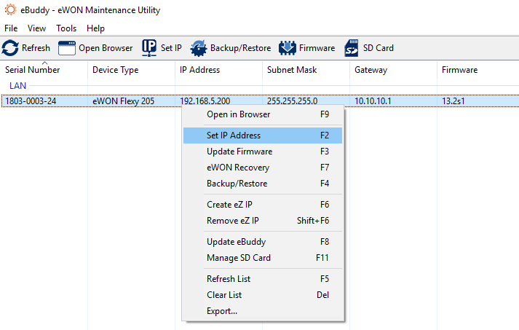
Once this is done make sure that your PC’s LAN ip address is set in the same range as the eWON’s.
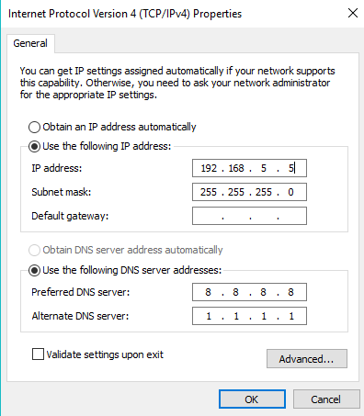

From here you can right click on the device in eBuddy and go to open in browser. We’re going to go through the System and Internet Wizard for this case.
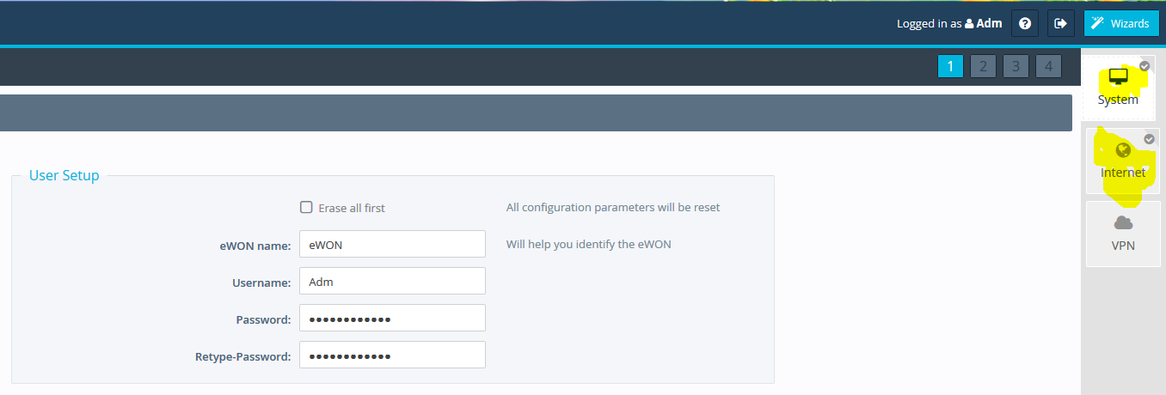

Step 2: Wizards
The System wizard will allow you to set a username/password, time, and choose which ports are LAN and WAN. After you complete the System wizard go to the Internet Wizard and select Ethernet Internet Connection.
In this case the device doesn’t need to be connected to the internet, this can just be viewed as a secondary network. But this can also be connected to your network’s WAN if you prefer this.
Note: If this is just being used on a secondary network (No internet access), don’t hit the check button on the Internet Connection Test.
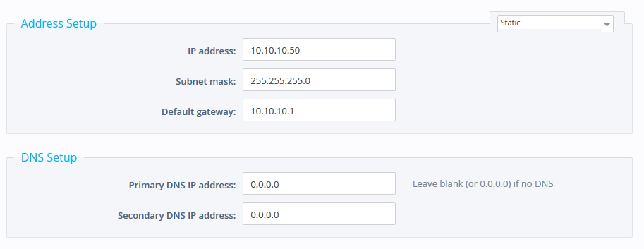
After this you can keep hitting next until the wizard is finished.

Step 3: Routing and COMCFG
Go to Setup > System > Communication > Networking > Security and make sure that these settings are checked:
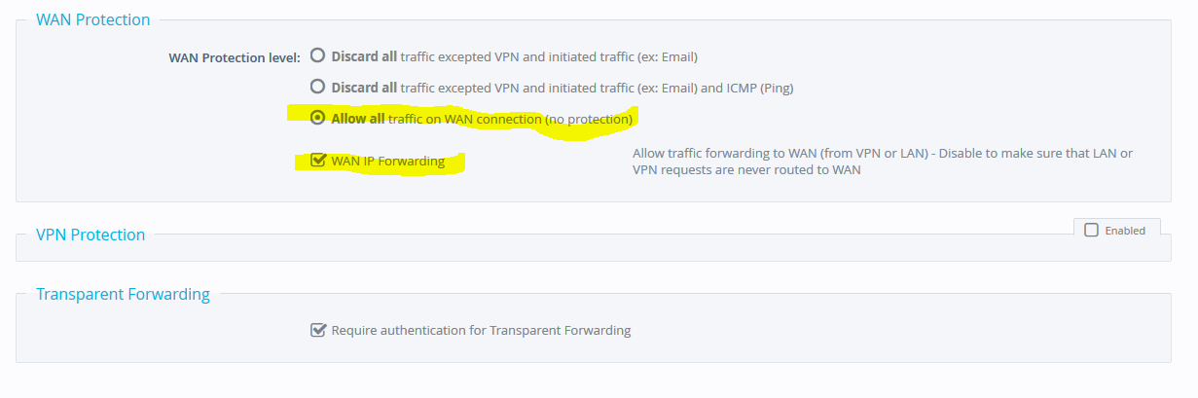
After that go to Networking > Routing and make sure these settings are checked:
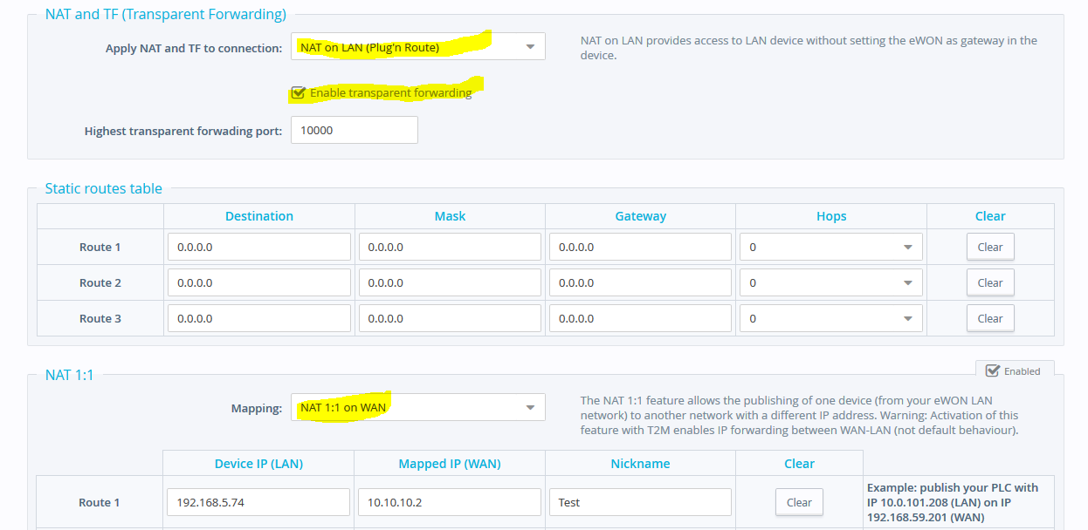
In this example, my eWON’s LAN address is set to 192.168.5.200 so it should be able to talk to anything on the 192.168.5.xxx range. I’m going to be connecting to an Anybus device that uses the IP address 192.168.5.74. Earlier we set our WAN address to be 10.10.10.50 so we should be able to talk on the 10.10.10.xxx range and we’re going to map that Anybus device to 10.10.10.2.

Step 4: ComCFG
Next we’re going to go to Setup > System > Storage > Tabular Edition > Edit COM cfg.
We are going to make the following changes:
- Search for FWRDtoWAN and set that to 1
- Search for WANITFPROT and set that to 2
- Search for NATITF and set this to 3
Once this is done reboot the unit and connect the cable that is going between your PC and the eWON to port 4.
You’ll now need to change your PC’s IP address to be in the same range as the WAN of the eWON
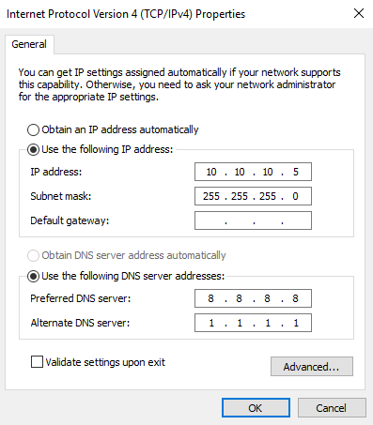
If this was done correctly you should be able to ping the WAN ip address of your device now.
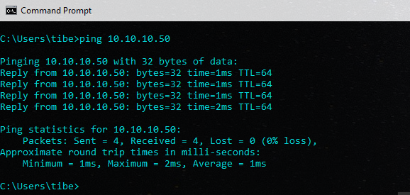

Step 5: PLC Settings
In this case I was connecting to an Anybus device and set its IP address to be in the 192.168.5.xxx range. Also make sure to set the Gateway of your device to match that of the LAN address of your eWON device
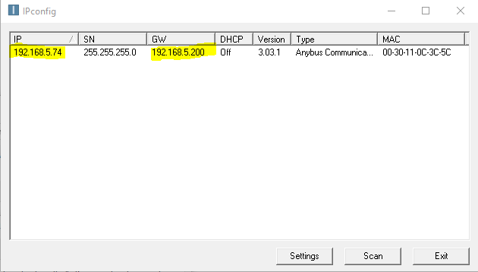
Once this is done you should now be able to test the NAT 1:1 mapping as seen below:
